Marvel API - MSP2 To-Do list

**CREATE A SINGLE PAGE APPLICATION THAT RELIES HEAVILY ON ONE OR MORE APIS**

* **Data must all be retrieved, no or minimal own data used**
* **Fixed header and footer, main section scrollable**
* **Searchbar fixed in navbar**
* **Home scroll button**
* **Search bar for characters, get additional data later Ended up under navbar because of space restrictions on mobile**
* **~~Bootstrap the page~~**
* **Materialized the page**

**For character:**

* **Show image, name, description and:**
* **comics**
* **series**
* **events**

**rough layout:**

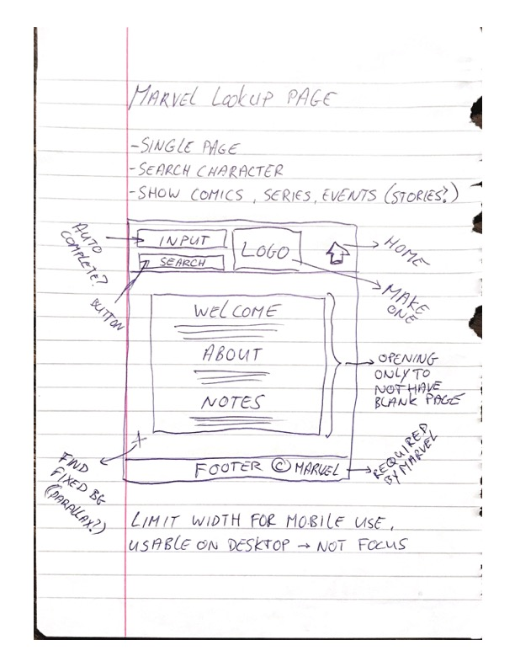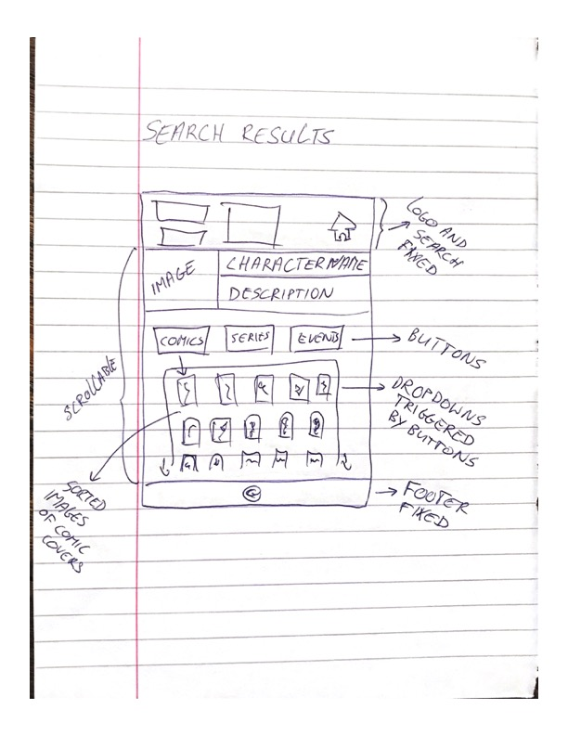

~~Each button drops a list of that type.~~

Collapsible implemented

* comics: Covers
* series: Name, description, image
* events: name, description, ~~image~~ Image too often missing, better without
* **caveat: Not all characters have description, add in link to Marvel site**

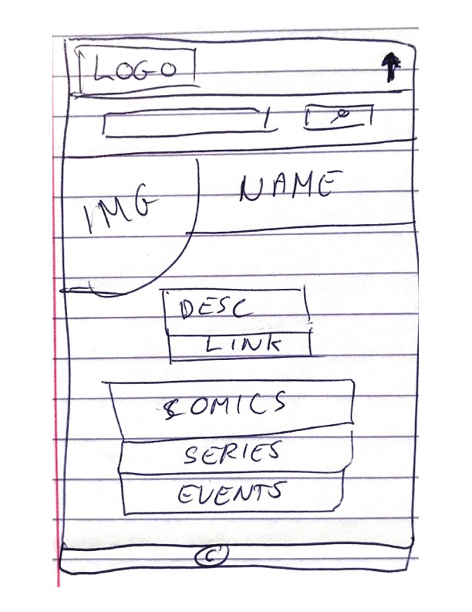

Solve return limits form API:

* add pagination solved by adding limits to retrieved data and using returned URI for paging

